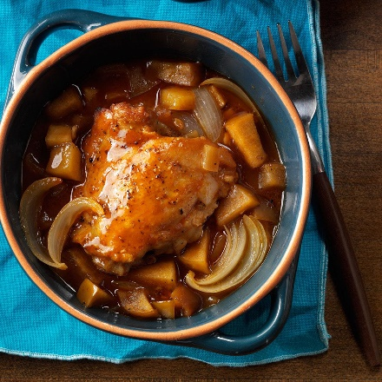
Autumn Apple Chicken
Prep time 20 min Cook time 30 min oven/3½ hrs slow cooker
4 Servings
Ingredients
1 tablespoon canola oil
1 lb boneless skinless chicken breasts
¼ tsp salt
¼ tsp pepper
2 medium Fuji or Gala apples, coarsely chopped
1 medium onion, sliced or chopped
1 garlic clove, minced
1/3 cup barbecue sauce
¼ cup apple cider or juice
1 tbsp honey
Directions
- In a large skillet, heat oil over medium heat. Brown chicken on both sides. Sprinkle with salt and pepper.
- Transfer to a covered baking dish or 3-qt. slow cooker. Top with apples.
- Add onion to same skillet. Cook and stir over medium heat 2-3 minutes or until tender.
- Add garlic and cook 1 minute longer.
- Mix together barbecue sauce, apple cider and honey and pour into the pan with onions and garlic. Increase heat to medium-high. Cook 1 minute, stirring to loosen browned bits from pan.
- Pour over chicken and apples. Bake covered at 325 degrees for 30 minutes or in crockpot on low 3½ to 4½ hours or until chicken is tender.

Freeze option
Separate into two portions. Freeze one half in a freezer safe container and cook remaining chicken and sauce as directed.

